Nama : Putri Norchasana

Kelas : 3D

NIM : 2241720036

1. System

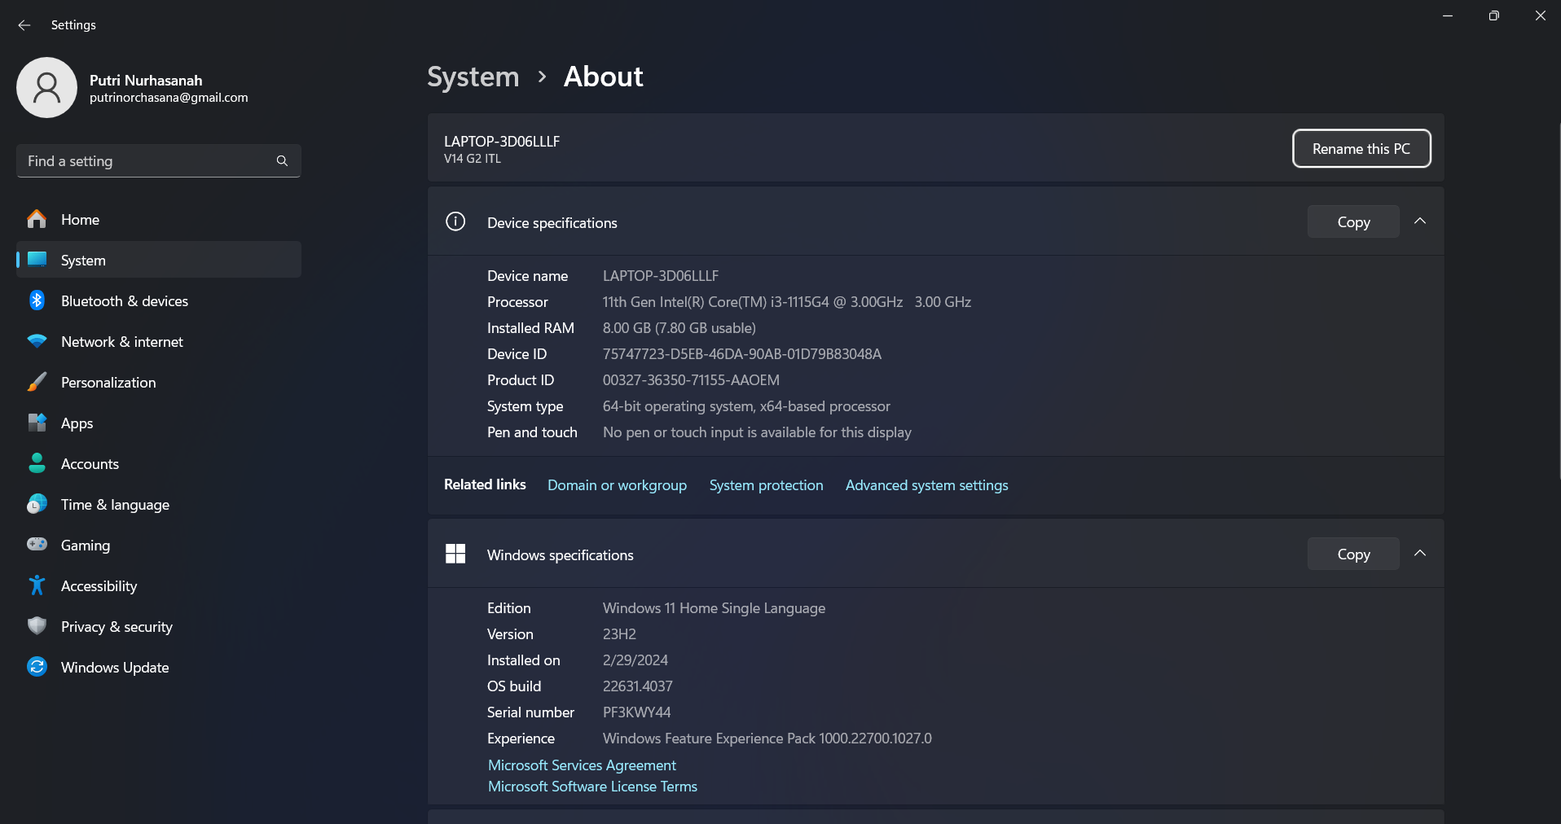

1. Git

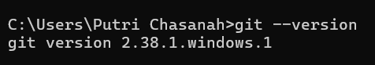

1. Flutter SDK

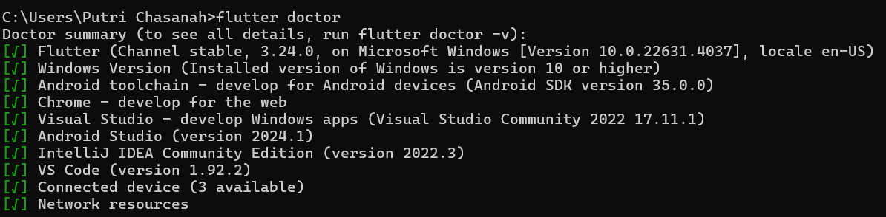

1. VS Code + Flutter Extension

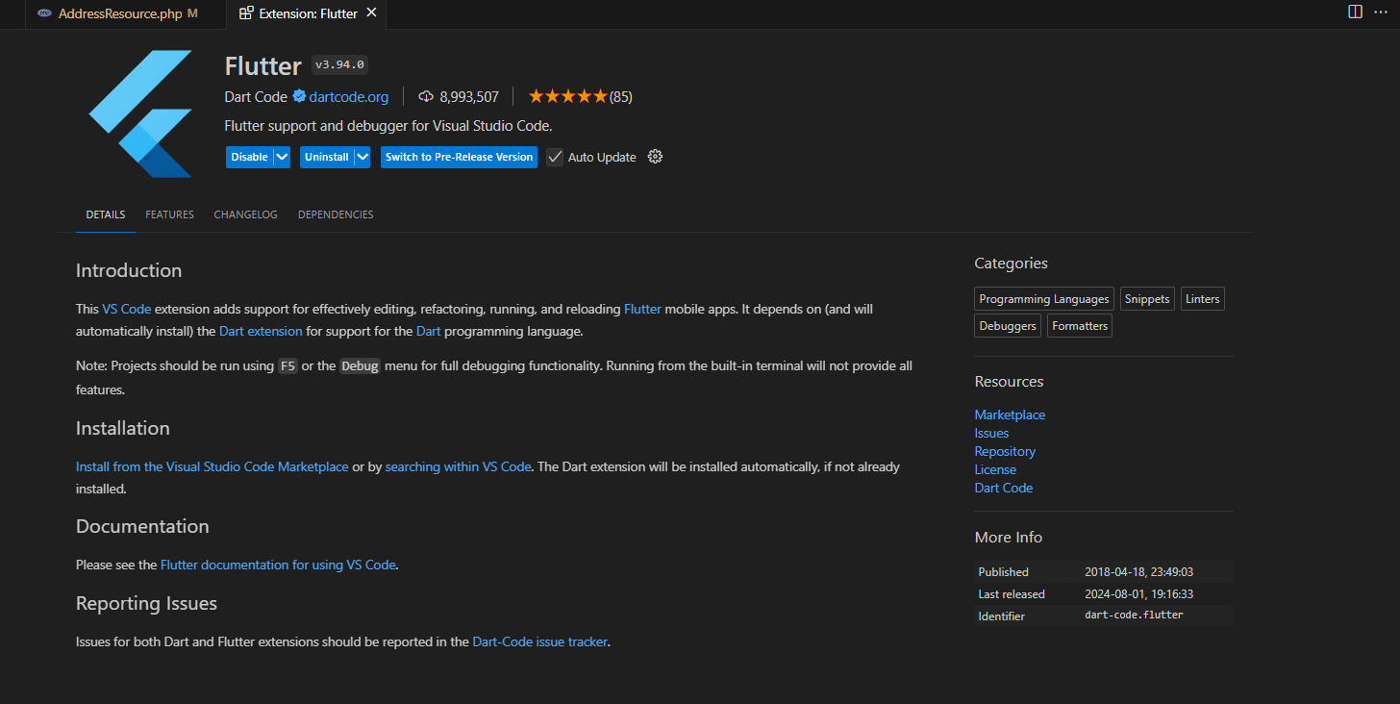

1. Android Studio

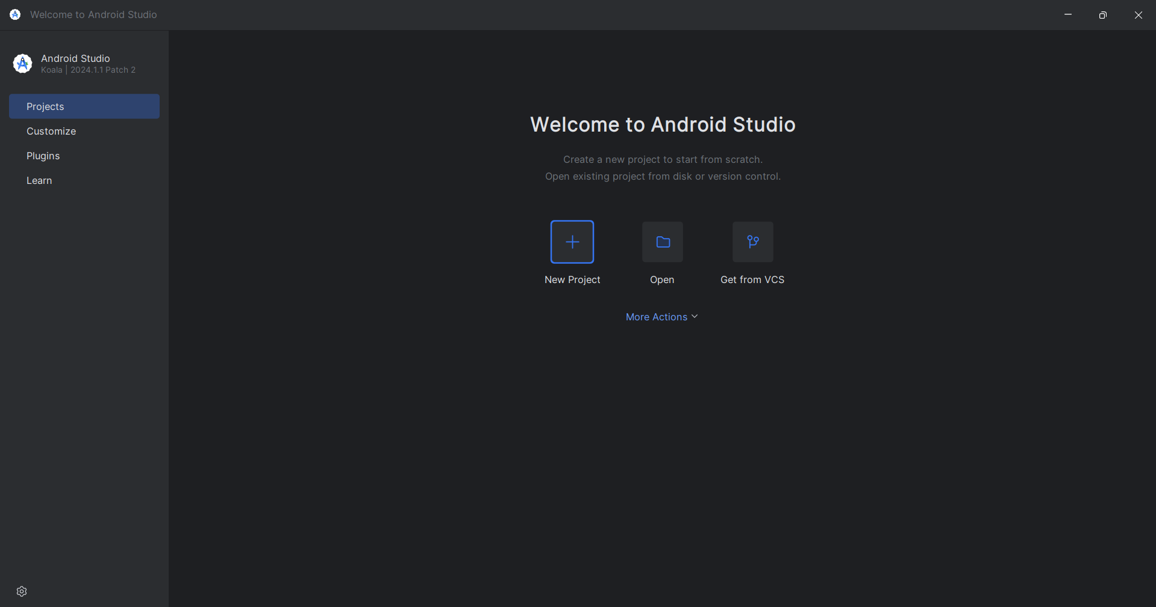

1. Android SDK

